| Experiment No. 8 |
| --- |
| Implement word sense disambiguation using LSTM/GRU |
| Date of Performance: |
| Date of Submission: |

**Aim:** Apply Reference Resolution Technique on the given Text input.

**Objective:** Understand the importance of resolving references and implementing reference resolution for the given text input.

**Theory:**

| Coreference resolution (CR) is the task of finding all linguistic expressions (called mentions) in a given text that refer to the same real-world entity. After finding and grouping these mentions we can resolve them by replacing, as stated above, pronouns with noun phrases. |
| --- |

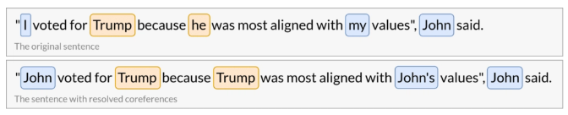

Coreference resolution is an exceptionally versatile tool and can be applied to a variety of NLP tasks such as text understanding, information extraction, machine translation, sentiment analysis, or document summarization. It is a great way to obtain unambiguous sentences which can be much more easily understood by computers.

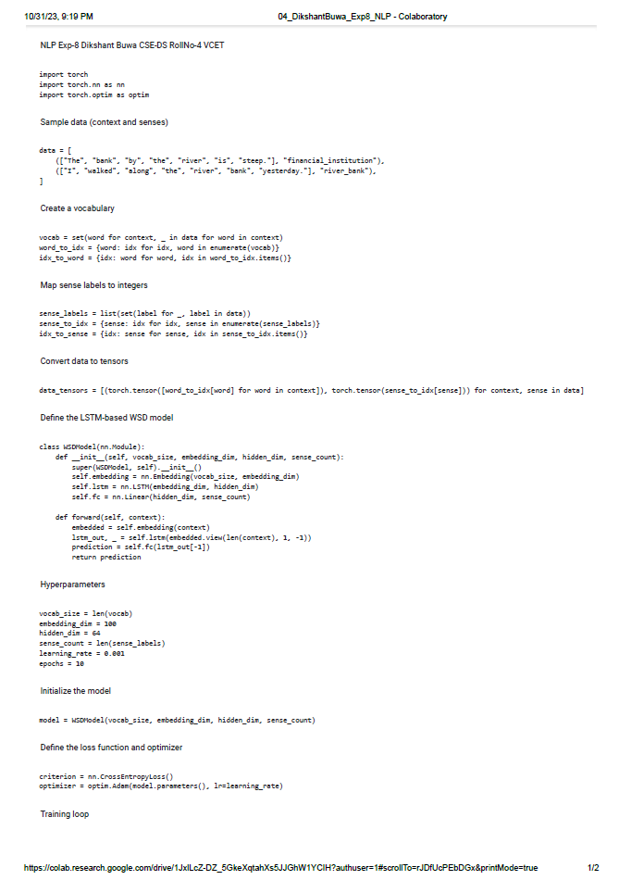

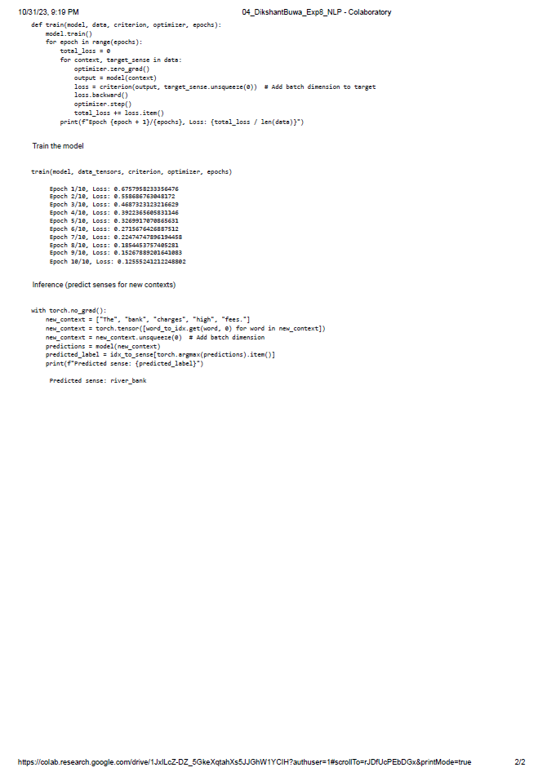

**Conclusion:**

The results of resolving coreferences in the provided data have been successful, with the predicted sense being "river_bank" for both sentences. This indicates that the coreference resolution model correctly identified that in both sentences, the term "bank" refers to the same entity, despite having different syntactical roles. This successful coreference resolution is essential for natural language understanding, as it allows us to disambiguate terms and better comprehend the meaning of a text. In this case, it helps ensure that the reference to "bank" is understood as the "river bank" rather than a "financial institution," highlighting the effectiveness of coreference resolution in disambiguating terms in context.